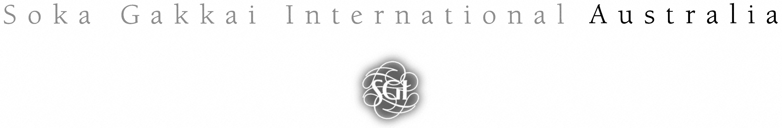
Overview Soka Gakkai International Australia (SGIA) Child Safe Policy

Soka Gakkai International Australia (SGIA) is a culturally and linguistically diverse community, celebrating the unique potential of each individual and their limitless capacity to contribute through strengthening friendships, celebrating diversity and fostering future generations to live a hope-filled life. SGIA recognises the significance of human rights both as a foundation for our organisational goals and activities and also as a legal responsibility. We recognise the responsibility to the children who are involved in our activities as a matter of unquestionable seriousness and reflect this in the SGIA Child Safe Policy. The rights of the child are of paramount importance both to our organisation and humanity’s future. SGIA is fully committed to preventing any accident or abuse that may befall a child within its activities and locations.

- SGIA is committed to protecting the rights of children without reservation to uphold the dignity of humanity and afford every right each individual must be afforded as stated in the UN Declaration of the Rights of the Child and United Nations Human Rights Charter.

- SGIA is committed to establishing a culturally diverse and safe environment in which the unique identities of Aboriginal children and young people are respected and valued.

- SGIA members, leaders and staff must be responsible for the protection of children from abuse and neglect and must report to senior leaders (State or National Leaders) and (in very urgent cases) the relevant government authorities any such abuse or neglect whenever it is witnessed or information concerning abuse or neglect is received as per the SGIA Child Safe Policy.

- SGIA requires of its volunteers and staff at all times to uphold the standards included in the SGIA Child Safe Policy.

- SGIA requires all staff and volunteers who organise and run activities with children and young people to hold current Working With Children Checks (or equivalent checks required by local legislation) as required by state and territory laws. In addition, such people must undergo training as prescribed by the leadership of SGIA and undergo training in the SGIA Child Safe Policy.

- SGIA leaders must check and confirm the safety of the environment in which children’s activities are conducted and report or correct any issues or dangers discovered in accordance with the SGIA Risk Management Assessment clauses 5.0 & 5.1 of the SGIA Child Safe Policy.

- The rights of the child must be held above any concerns for the name or status of SGIA and authorities must be included in all reporting of child abuse or neglect, while complying with the principles of procedural fairness summarised at clause 8.1 of the SGIA Child Safe Policy. The privacy of the child must be upheld throughout any process of reporting or inquiry.

In Summary SGIA is committed to:

- Respecting the dignity and rights of all children.

- Embedding child safety and wellbeing in our governance, organisational leadership and culture.

- The prevention of all possibilities of child abuse or accidents within its Ability.

- Fulfilling all of our social, legal and moral responsibilities regarding child safety, abuse or neglect.

- Ensuring a safe, inclusive environment for children in all the activities of SGIA.

- Providing appropriate professional access, support, non-judgemental engagement and guidance for any child victimised by abuse or neglect.

- Ensuring all leaders, volunteers, members and parents understand the significance of and are involved in championing and implementing child safety practices.

- Ensuring appropriate support, checks, training and attitudes of those leaders with children in their care.

- Ensuring equity is upheld, racism is identified, confronted and not tolerated and the inclusion of children from indigenous, culturally or linguistically diverse backgrounds and children with disabilities.

“The welfare of people must always be the starting point and final goal of every human endeavour. As such, it is unacceptable for religion,
government or any ideological system to treat people as a means to an
end." - Daisaku Ikeda

